Final Semester Exam for Database Systems
Girls’ Boarding House Information System



Lecturer by:
Asmunin, S.Kom., M.Kom.
Written by :
Aisyah Currents
25091397108
International Class 2025

INFORMATIC MANAGEMENT MAJOR
FACULTY OF VOCATION
UNIVERSITAS NEGERI SURABAYA
YEAR 2026

BUSINESS PROCESS AND MODULES
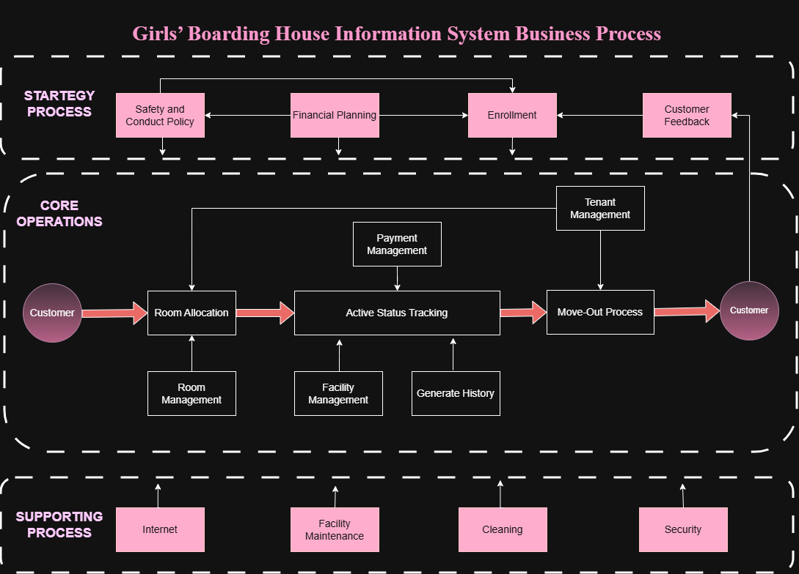
Figure 1. Business Process Diagram
The Girls’ Boarding House Information System business process begins with strategic planning activities such as creating safety and conduct policies, financial planning, tenant enrollment, and collecting customer feedback. After registration, customers enter the core operational process where rooms are allocated based on availability. Room allocation is supported by room management activities. During the tenant’s stay, the system monitors active status tracking, payment management, facility management, and generates tenant history records. When tenants finish their rental period, the move-out process is conducted through tenant management procedures. Supporting processes such as internet services, facility maintenance, cleaning services, and security ensure that boarding house operations run effectively and comfortably for tenants. Modules included in the Business Process are :
- Room Management
The Room Management module is used to manage room data, including room availability, room types, room prices, and room conditions. This module helps administrators monitor which rooms are available or occupied.
- Tenant Management
The Tenant Management module manages tenant information such as personal data, contact information, room assignments, and tenant status during their stay in the boarding house.
- Facility Management
The Facility Management module manages boarding house facilities such as WiFi, kitchen areas, laundry services, cleaning services, and security facilities to ensure tenant comfort and operational efficiency.
- Payment Management
The Payment Management module is responsible for recording rental payments, monitoring payment status, and managing tenant transaction records for each payment period.
- Report History
The Report History module generates reports related to tenant activities, payment history, room occupancy, and other operational data that help administrators monitor and evaluate boarding house operations.

THE ENTITIES
The Girls’ Boarding House Information System consists of several important modules that support boarding house operations and management activities. Each module contains entities that store and manage specific data required by the system. These entities are interconnected to help administrators organize tenant information, room availability, payment transactions, facility data, and operational reports efficiently. The following are the entities involved in each module of the system.
- Tenant Management
m_tenant (tenant_id, name, phone, address, emergency_contact), The Tenant entity is used to store tenant personal information such as tenant name, phone number, address, and emergency contact. This entity helps administrators manage and monitor all tenant data in the boarding house system.
- Room Management
m_room (room_id, room_number, type, price, status), The Room entity stores information related to boarding house rooms, including room number, room type, room price, and room availability status. This entity helps administrators manage room occupancy and room conditions.
- Facility Management
m_facility (facility_id, name, condition, description), The Facility entity stores information about facilities provided by the boarding house, such as WiFi, kitchen, laundry room, and parking area. It also records facility conditions and descriptions for maintenance purposes.
- Payment Management
t_payment (payment_id, tenant_id, room_id, amount, payment_date, status), The Payment entity records all payment transactions made by tenants. It stores information such as payment amount, payment date, room rented, and payment status to help manage financial records and monitor monthly rent payments.
- Report History
r_history (report_id, tenant_id, room_id, payment_id, report_date, description), The ReportHistory entity is used to generate and store reports related to tenant activities, payment history, and room occupancy. This entity helps administrators monitor boarding house operations and maintain historical records.

ENTITY RELATIONSHIP DIAGRAM

THE CARDINALITY

DATABASE NORMALIZATION PERFORM

THE NORMALIZED DATABASE DESIGN IN MYSQL

SQL COMMANDS

CRUD OPERATIONS ON 2 SELECTED MASTER TABLES

